**Restaurant Automation System**

**User Manual**

This section shows latest news about the restaurant

**Users of System:**

1. Customers

2. Admin

**Main page of website:**

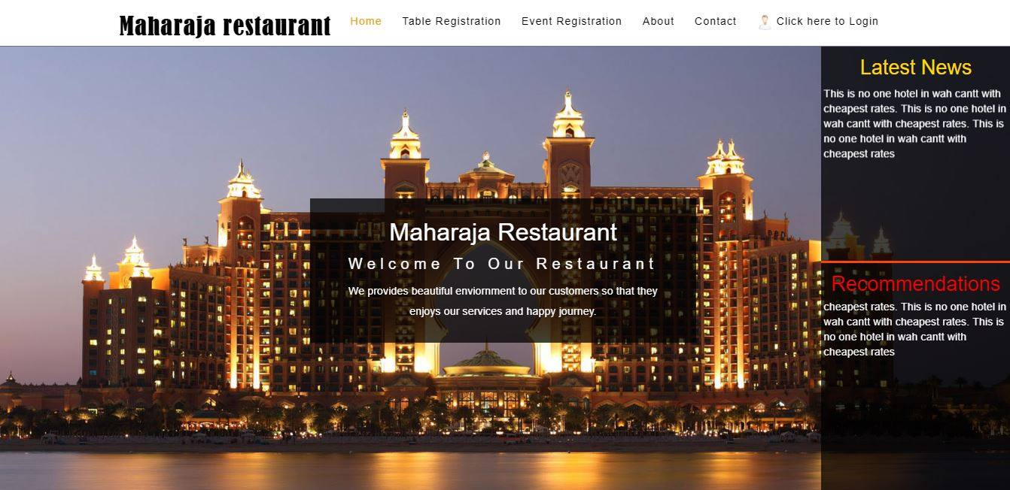

This text box shows recommendations to customers

Section No.1 having links of different pages

**Section2**

When user clicks on the table reservation link it shows this form that user must have to fill.to reserve the table

Section 2 is the web page which will appear which is given.

Reservation date

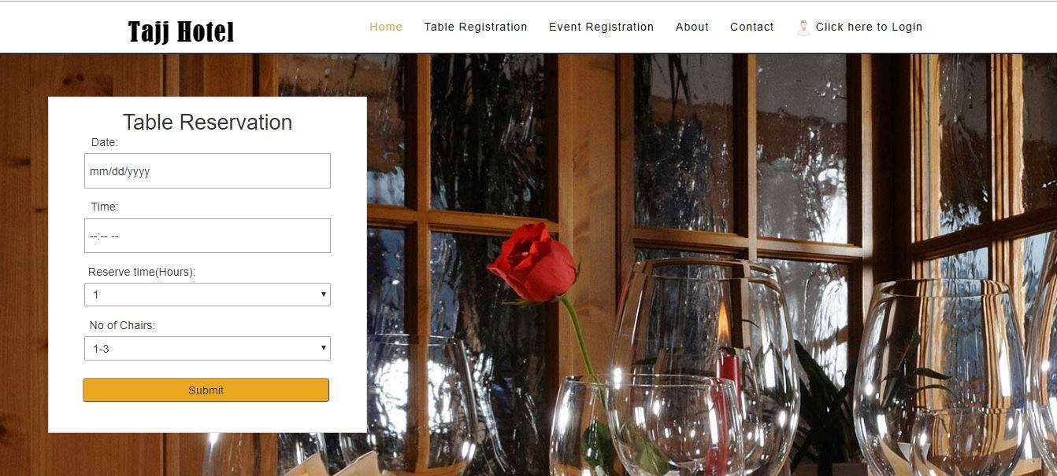

Submit button to

No of chairs that user wants

Reservation time

This link have table reservation form when user click on it shows form that user must have to fill to reserve the table

**Section 3**

When user clicks on the event reservation link it shows this form that user must have to fill. to reserve the event

Event reservation link on the home page

Section 2 is the web page which will appear which is given.

Section 2.2 is the web page which will appear is given.

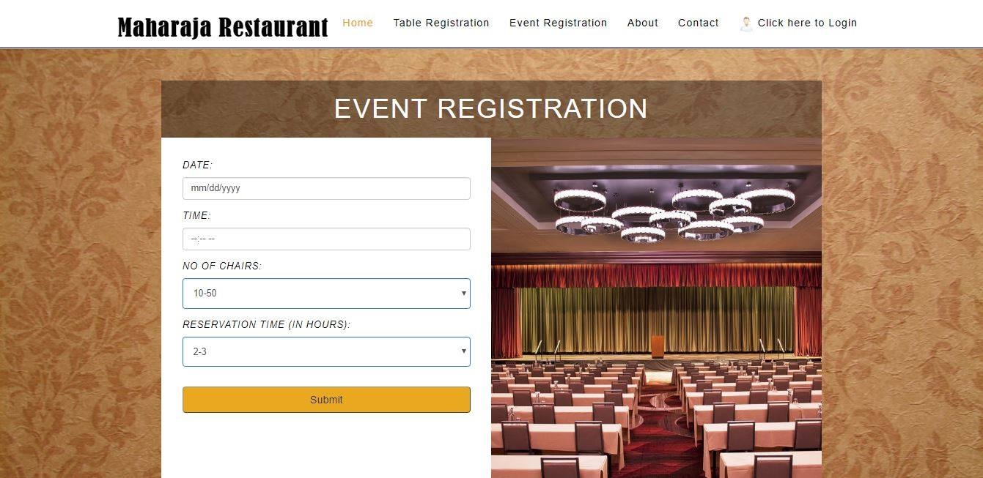

Reservation time

Time of the reservation

Reservation time

Event reservation form

**Section 4 (IMPAIRED BOTH).**

This link shows information about the restaurant and important details for the ease of customers

Information about the restaurant the web page which will appear is given.



**Section contact**

This link has contacts of the restaurant management and address of the restaurant

When user clicks on the contacts link it shows address and contacts of the restaurant and management.



**Section sign up**

When new user visits the web site and want to reserve the table it has to make an account .the given page is showing sign up form

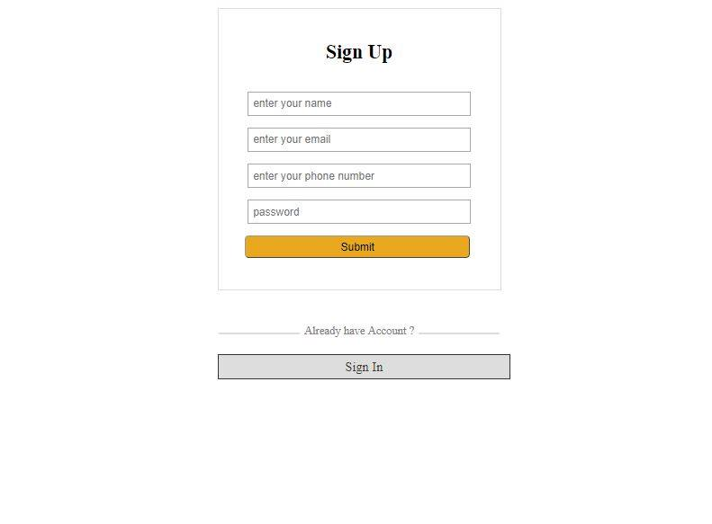

Submit button to submit the details

User password

User name

User active email

Users cell no

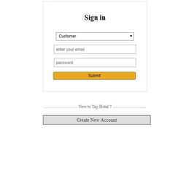

Email of the user

Password

Account type, customer or admin

**Menu items**

When user sign-in in the account then this form is shown to customer that contains menu items and recommended items

Items that are most purchased by customer.

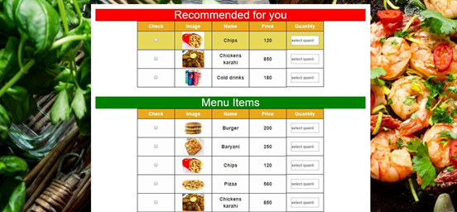

Items that restaurant have for the customers